**wPortal demo installation**

Version 4.6.0.0

**Summary**:

wPortal demo installation process

**Contents**

1 Document Information 3

1.1 History 3

1.2 Mailing List 3

1.3 Related Documents 3

2 Install wPortal demo 4

3 Configuration 5

3.1 Install IIS 5

3.2 Configure IIS (only for IIS 6) 5

3.3 Configure IIS (only for IIS 7) 8

3.4 Test installation 11

3.4.1 Purpose 11

3.4.2 Procedure 11

3.4.3 Expected result 12

3.4.4 Known issues : 12

4 Configure and launch AppServer 13

4.1 Configure Server 13

4.2 Launch Server 13

5 Access wPortal 14

6 End of document 15

1. Document Information
   1. History

|  |  |  |  |
| --- | --- | --- | --- |
| **Version** | **Modifications Description** | **Author** | **Date** |
| 0.1 | Document creation | JP Roger |  |
| 4.5.0.0 | update | JP Roger |  |
| 4.5.0.1 | Update of virtual directory name in IIS configuration | JP Roger | 2/11/2011 |
| 4.6.0.0 | Version update | JP Roger | 12/01/2012 |

* 1. Mailing List

|  |  |  |
| --- | --- | --- |
| **Name** | **Company** | **Email** |
|  |  |  |
|  |  |  |
|  |  |  |

* 1. Related Documents

|  |  |
| --- | --- |
| **Name** | **Description** |
| wPortal – Framework overview | Framework overview |
| wPortal – Demonstration script | Functional demo script |
| wPortal – Demo installation | Demo installation manual |
| wPortal – Installation | wPortal installation manual |
| wPortal – Technical demo script | Technical demo script |

1. Install wPortal demo

Unzip wPortal demo in D:\ in order to have a folder “D:\wPortal46\bin”.

Others locations are possible, but you will have to modify your variable WYDE-ROOT in D:\wPortal46\bin\EWAM Set Env.bat.

1. Configuration

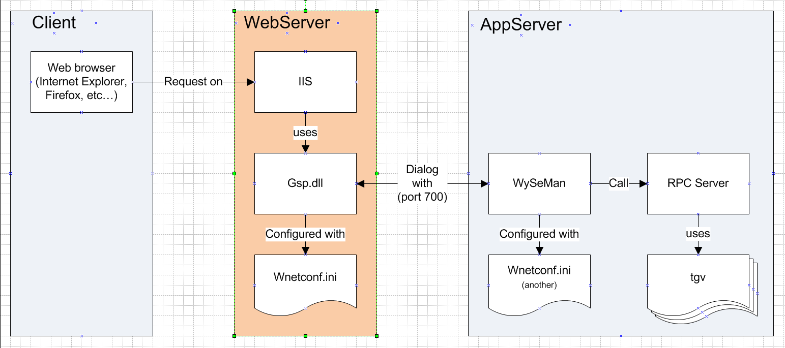

* 1. Install IIS
* For windows vista, windows 2003, windows 7
  1. Click on “Control Panel” 🡺 “Programs” 🡺 “Turn Windows features on or off”
  2. Check “Internet Information Services” (full check)
  3. Validate
* For Windows XP
  1. Click on “Control Panel” 🡺 “Programs”
  2. Click on “Add or remove Windows features” on left tab
  3. Check “Internet Information Services” (full check)
  4. validate
  5. Configure IIS (only for IIS 6)

1. Open IIS service manager
2. Create an Application Pool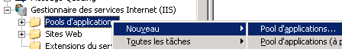
   1. Name : wPortal_AppPool
3. Create three Virtual Directories :  
   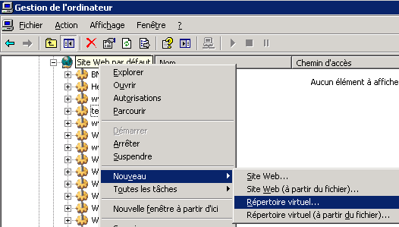
   1. Client virtual directory
      * Right click on “Default Web Site” 🡺 New 🡺 Virtual Folder…
      * Alias : **liclient**
      * Path : C:\inetpub\wwwroot\wPortal46
      * Authorization : Read and Execute(ISAPI)
      * Validate
   2. Broker virtual directory
      * Right click on “Default Web Site” 🡺 New 🡺 Virtual Folder…
      * Alias : **libroker**
      * Path : C:\inetpub\wwwroot\wPortal46
      * Authorization : Read and Execute(ISAPI)
      * Validate
   3. Group admin virtual directory
      * Right click on “Default Web Site” 🡺 New 🡺 Virtual Folder…
      * Alias : **ligroupadmin**
      * Path : C:\inetpub\wwwroot\wPortal46
      * Authorization : Read and Execute(ISAPI)
      * Validate
4. Configure all Virtual Directories
   1. Right click on liclient virtual directory 🡺 Properties  
      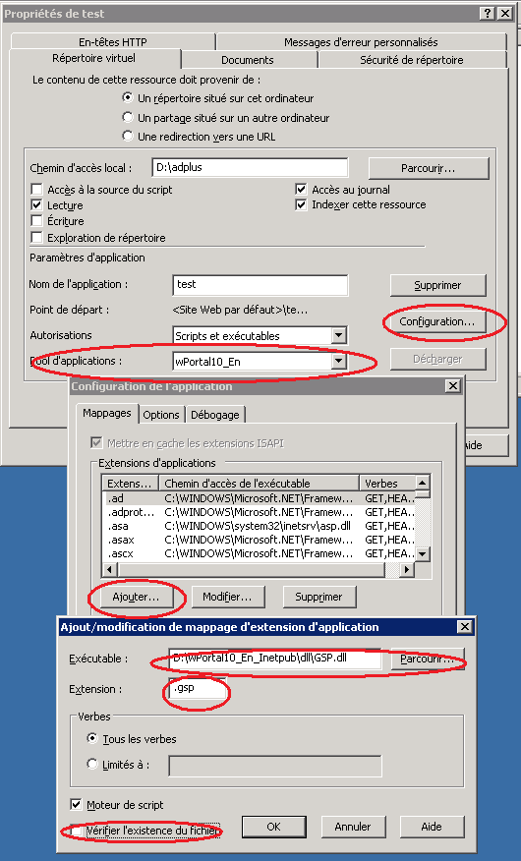
   2. Application Pool : wPortal_AppPool
   3. Click on “Configuration…” Button
      * Click on “Add…” button
      * Executable : C:\inetpub\GSP\GSP.dll
      * Extension : “.html”  
        *(without quote)*
      * Uncheck “Verify if file exists”
   4. Follow the same procedure for libroker and ligroupadmin virtual directories.
5. Add a new Web Service Extension  
   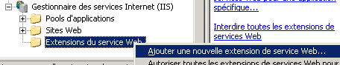
6. Name : wPortal_Ext
7. Add all files in C:\inetpub\GSP\*.*
8. Authorize the Web Service Extension
9. Restart IIS
   1. Configure IIS (only for IIS 7)
10. Open IIS service manager
11. Create three Virtual Directories  
    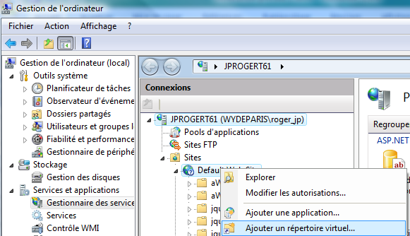
    1. Client virtual directory
       * Right click on “Default Web Site” 🡺 New 🡺 Virtual Folder…
       * Alias : liclient
       * Path : C:\inetpub\wwwroot\wPortal46  
         *(the folder containing : js, css, theme… folders)*
       * Validate
    2. Broker virtual directory
       * Right click on “Default Web Site” 🡺 New 🡺 Virtual Folder…
       * Alias : libroker
       * Path : C:\inetpub\wwwroot\wPortal46  
         *(the folder containing : js, css, theme… folders)*
       * Validate
    3. Group admin virtual directory
       * Right click on “Default Web Site” 🡺 New 🡺 Virtual Folder…
       * Alias : ligroupadmin
       * Path : C:\inetpub\wwwroot\wPortal46  
         *(the folder containing : js, css, theme… folders)*
       * Validate
12. Configure the default web site
    1. Click on Default Web Site 🡺Default document :  
       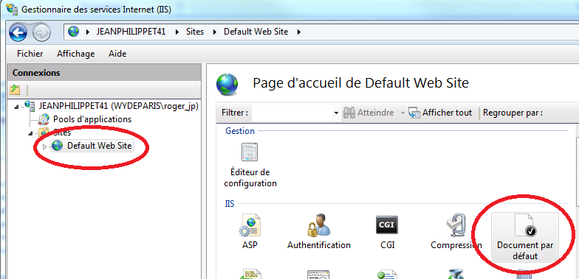  
       Remove all document then add “index.html” :  
       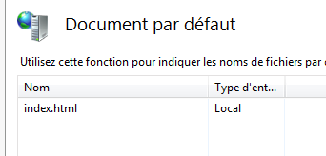
    2. Click on Default Web Site 🡺 mapping manager  
       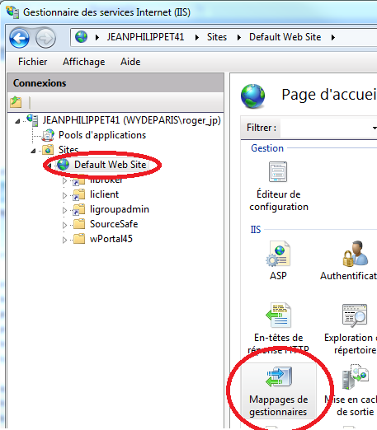  
       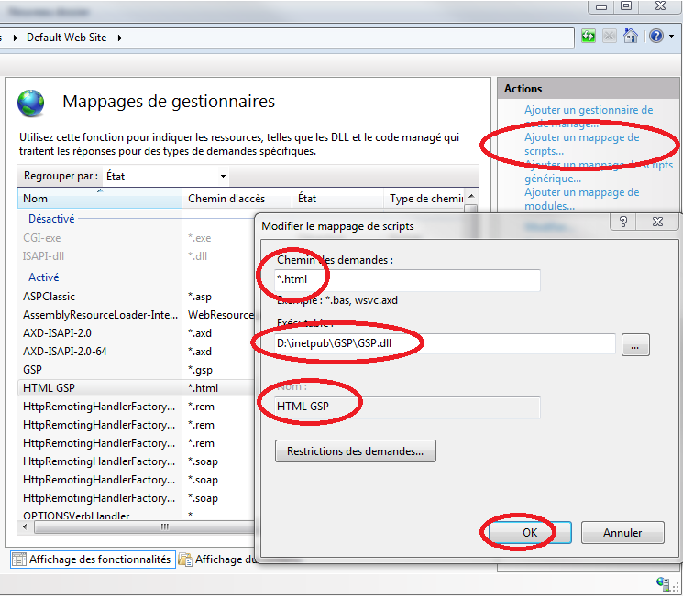
    3. Click on “Add Script Map…” link on the right panel
       * Extension : “*.html”  
         *(without quote)*
       * Executable : C:\inetpub\GSP\GSP.dll
       * *Name : HTML GSP*
       * *Validate and click ‘yes’*
13. Restart IIS (not only the Default Web Site)
    1. Test installation
       1. Purpose

Test communication and configuration between your browser and GSP.dll.

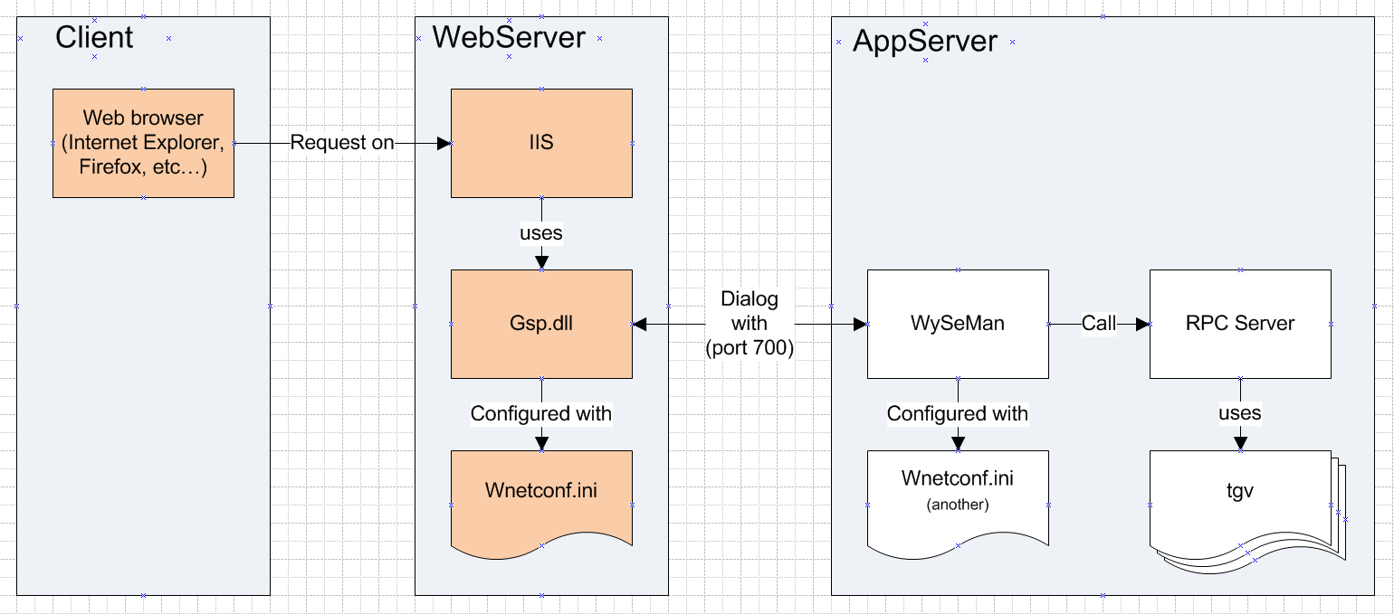

* + 1. Procedure

1. You can test the configuration by typing the following url on the client browser:   
   <http://localhost/liclient/wnetconf.html>
2. If this test doesn’t work, you won’t be able to go further. Notice the following paragraph “Known issues” can help you.
   * 1. Expected result

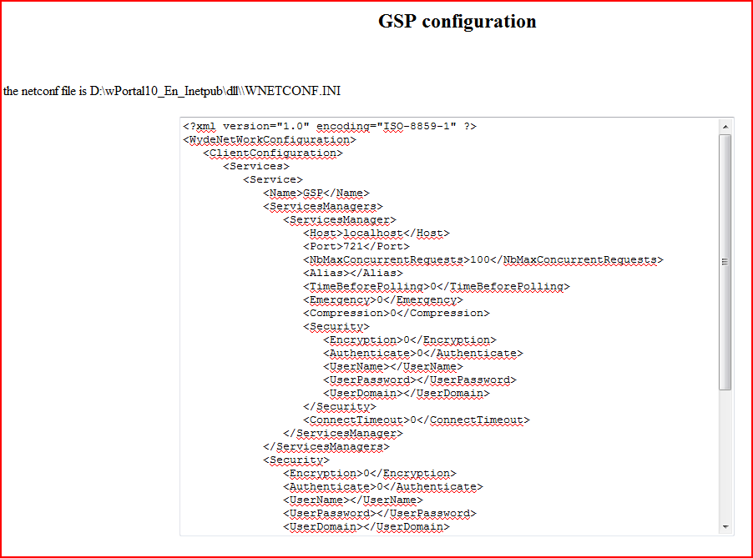

* + 1. Known issues :
  + If the result is a white page, maybe with a few characters, try to disable antivirus, and call back the url.
  + If you are trying to configure GSP.dll (32bit) on a 64 bit OS :
    - For IIS 6  
      IIS 6 cannot handle it without a few manipulations. try this : <http://support.microsoft.com/kb/894435/fr>  
      This paragraph has been particularly useful for me :  
      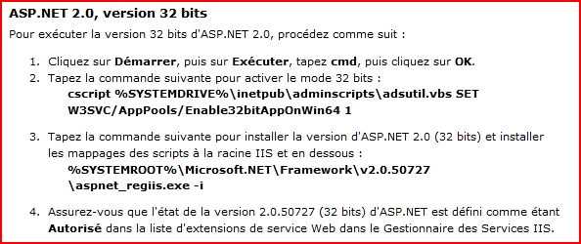
    - For IIS 7  
      Go on your application pool and go to advanced configuration, you should find an option to authorize the application pool to launch 32 bit dll.

1. Configure and launch AppServer
   1. Configure Server

You may have to modify (WYDE-ROOT)\bin\EWAM Set Env.bat if you have unzipped wPortal in a specific location.

* 1. Launch Server

Several servers can be launched, only one can be launch at a time. To launch a server, double click on the corresponding batch:

|  |  |  |
| --- | --- | --- |
|  | Dynamic Multilang | Static language |
| English database | D:\wPortal46\bin\_WSMServerML-EN.bat | D:\wPortal46\bin\_WSMServerEN.bat |
| French database | D:\wPortal46\bin\_WSMServerML-FR.bat | D:\wPortal46\bin\_WSMServerFR.bat |

1. Access wPortal

In your browser, type the following url:

|  |  |
| --- | --- |
| To access client portal | <http://localhost/liclient/> |
| Broker portal | <http://localhost/libroker/> |
| Group admin portal | <http://localhost/ligroupadmin/> |

1. End of document